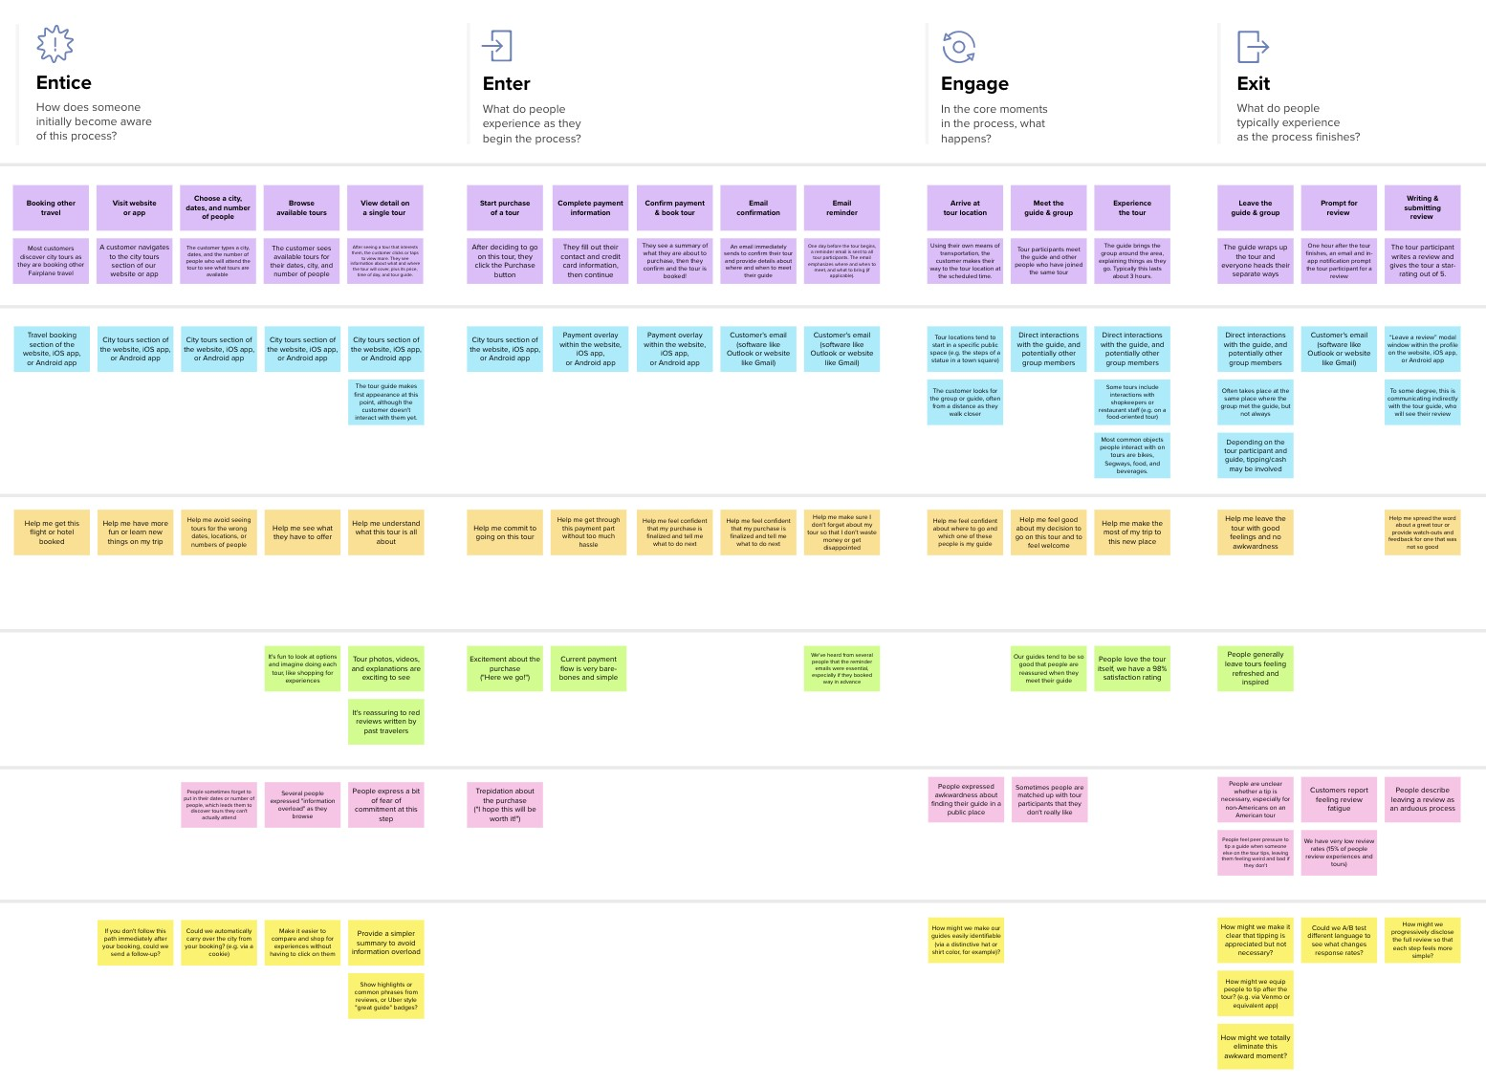

Customer experience journey map

Use this framework to better understand customer needs, motivations, and obstacles by illustrating a key scenario or process from start to finish.

When possible, use this map to document and summarize interviews and observations with real people rather than relying on your hunches or assumptions.

Created in partnership with

**Personal Assistance for seniors who are self reliant..**

# Entice

**SCENARIO**

**An app or website will be created in that time and medicine to be taken will be updated in that database**

How does someone initially become aware of this process?

**Steps**

**Select the time and medicine**

**Details**

**Open the app/website**

**Time and medicine**

**Will be enter**

What does the person (or group) typically experience?

Its easy for customer to set time

A Customer Navigates to the setting section of our app/website

The customer types the time and medicine details

For their need

## Interactions

Setting section of the Android App or website

Setting section of the Android App or website

Reminder section of the Android App or website

What interactions do they have at each step along the way?

**People:** Who do they see or talk to?

**Places:** Where are they?

**Things:** What digital touchpoints or physical objects would they use?

Help me to set correct time and medicine details

Help me to go to setting section

Its help me to reminder

Help me make sure i don't forget about setting time

Reminder helps me to feel confident while taking the medicine

# Enter

What do people experience as they begin the process?

**Easy to Use**

**Its easy to handle the device**

Customers are feeling it is very easy to use

Customers want their devices or apps to be simple to use

Setting section of the Android App or website

Setting section of the Android App or website

# Engage

In the core moments in the process, what happens?

**Cost free**

**Schedule the requirements of the patient**

**Saves Time**

**Saves Money**

Customers feel that it is cost free to use

Customers can able to manage and keep track of their schedules

They feel it saves time for taking care of elders and can go to work

It saves money which used for keeping caretakers for taking care of elders

It often interacts with Android app or website

It often interacts with Android app or website

# Exit

What do people typically experience

as the process finishes?

**Leave the App**

**Writing And Submitting Review**

They can close the app and use any other

The customer can write reviews about the app

"Leave a review” modal window within the profle in iOS app,

or Android app

# Extend

What happens after the experience is over?

**Personalized suggestions**

**Personalized recommendation**

They are able to provide suggestions to others about this app

They can recommend this app to others

Recommendations span across

iOS app, or Android app

## Goals & motivations

At each step, what is a person’s primary goal or motivation? (“Help me...” or “Help me avoid...”)

It is helpful to use this sytem

it used to organise your medication doses for a certain length of time.

If there is change in time zone during travelling it should have the ability to change accordingly

It has ability to share the medication information to third party for example ,family member or health care provider

## Positive moments

What steps does a typical person find enjoyable, productive, fun, motivating, delightful, or exciting?

App is secure because having password acesses

Some customers feel productive by doing this

[**Share template feedback**](https://muralco.typeform.com/to/CiqaHVat?typeform-source=app.mural.co)

No need for care takers to remind

It gives comfort for a patient to take medicine

Its exciting to look at options to get reminder using voice commands

Availability of an option to alert other people about when to take their medication

People love the app having good rating

Availability of a feature that rewards the patient when the medication is taken on schedule

Use of multiple language is possible

## Negative moments

If the customer didn’t get notification it may lead to sever problem

They may feel frustrated if they didn't understand how to set the time and medicine details

They feel that it may not provide security of the person details

Instead of trying this they can go for Physical medications methods

Most of the customers will not believe it will work or not

They will get fear for taking the wrong medication

Some people will feel it difficult to

Set up the app

Some customers will get confuse to set the time like A.M or P.M

Elder people find difficult in using the app

What steps does a typical person find frustrating, confusing, angering, costly, or time-consuming?

Some people may enter wrong time and wrong medicine

If the medicine Is going to end may be having an reminder before 2 days to consult the doctor

**Need some inspiration?**

It uses an alarm cue to prompt users to take medication.

Help me spread the word about a app and feedback for one that was not so good

Help me to Leave the app with good experience

Using this system can take medicine easily and regularly

Help me to see the ways o enhance the app

It decreases medication dispensing errors and wrong dosages.

Help me to tell what to do next

It helps to track and uphold an appropriate schedule.

**Template**

See a finished version of this template to kickstart your work.

[**Open example**](https://app.mural.co/template/f59f644b-b4b4-47b5-9ed6-3a8c71ceb612/896b31fe-5597-40ef-9b06-3811a1a45ace)

## Areas of opportunity

We can use this to create database for a hospital to maintain over al patient details

How might we make each step better? What ideas do we have? What have others suggested?

Can be having an update of a customer health for each day

Provide a medicine bottles with labels by using colored tape etc..

Make the app user friendly manner

Keep an up-to-date list of your medication names, strengths, doses, and number of remaining refills

Marking your daily doses on a paper calendar at home, on your computer or even in your little black book

Put your pillbox in a place where it will remind you to take your medicines.

Using a plastic pillbox with dividers for each day's medicines.

Providing trendy reminder device which can be wearable.